Jonesborough Farmer’s Market Sales System and Website

**Top Level Requirements Document**

|  |  |  |  |  |  |
| --- | --- | --- | --- | --- | --- |
| **Document Version** | **Comment** | **Date** | **Developers** | **Client Signoff** | **Date** |
| **2.0** |  | **12/1/2013** | Software Systems Engineering Group 1 |  |  |

**Contents**

**Executive Summary**

**Introduction**

**Client and User Profile**

**Scope**

**System Definition**

System Level Diagram

Functional Requirements

Non-functional Requirements

User-Interface Requirements

Data Storage Requirements

# Executive Summary

This document contains the Top Level Requirements (TLR) for the **Jonesborough Farmer’s Market Sales System and Website.**  The Executive Summary is an abbreviated representation of the full TLR document that follows.

## Client

Jonesborough Farmer’s Market

## Sponsors

Dr. Martin Barrett

Karen Childress

## Users

**Administrators** – system managers for sales system and website

**Growers/Vendors** – provide produce and other products to be sold

**Volunteers** – help with various aspects of the operation of the market

**Donors** - give money

**Customers** – purchase produce and other products from the market

## Document Summary

The scope of the project includes the development of a web-based application designed to allow customers to view and place orders for available products, allow registration of volunteers, allow administrators to collect data about volunteers, and allow potential product or service providers to apply for registration as vendors. It will interface with a Point of Sale system for payment processing. The goals of the system are to allow the Jonesborough Farmer’s Market to serve and promote the products offered by the local community.

The TLR document concludes by defining the system at a high level through the use of a system level diagram followed by a listing of the requirements that must be met in order to achieve the goals of the system within the scope summarized in the previous paragraph. Included in these requirements are ones that must be met to enable each of the different user functions (Functional Requirements), constraints on the system such as the requirement that the application will be web-based (Non-Functional requirements), definition of the web pages presented to users (User Interface Requirements), and the requirements defining how information is maintained (Data Storage Requirements).

**Introduction**

As stated in the Executive Summary, this document contains the Top Level Requirements for the **Jonesborough Farmer’s Market Sales System and Website.** It includes profiles of the client and the different user classifications. Next, the scope of the project is defined at a high level. Finally, a system definition is presented through the use of a system level diagram, a listing of functional, non-functional, user interface, and data storage requirements.

The system to be developed is a web-based application designed to allow customers to view and place orders for available products, allow registration of volunteers, allow administrators to collect data about volunteers, and allow potential product or service providers to apply for registration as vendors. It will interface with a Point of Sale system for payment processing.

The goals of the system are to allow the Jonesborough Farmer’s Market organization to serve and grow its customer base, elicit and grow its volunteer base, plus promote the products and services offered by the Jonesborough community.

# Client and User Profile

The client is the Jonesborough Farmer’s Market which is a community market organized by volunteers for the direct sale of farm raised produce and homemade products.

## Project Sponsors

Dr. Martin Barrett (423) 439-7409, [barrettm@etsu.edu](mailto:barrettm@etsu.edu)

* Dr. Barrett is Assistant Department Chair for the East Tennessee State University Department of Computing. He is the customer liaison for this project – all direct communication with the Jonesborough Farmer’s Market is handled by him.

Karen Childress (423) 753-4744, [jbofarmersmarket@gmail.com](mailto:jbofarmersmarket@gmail.com)

* Mrs. Childress is the Executive Director. She serves as the main customer contact for Dr. Barrett.

## User Profiles

### Administrators

Administrators are market managers and other individuals familiar with the market, interacting with the sales system, and navigating the website. They perform the following functions:

* Assign security roles to users
* Manage products
* Manage dividends/benefits system
* Email users
* Update blog
* Create barcodes
* Schedule volunteers

## Growers and Vendors

Growers and vendors are members of the community that provide either produce or homemade products for sale. There will be a wide variance of computer skills among this class of user; some may have little or no experience navigating websites. Growers and Vendors perform these functions:

* Add products to inventory
* Set prices for his/her products

## Volunteers

Volunteers are members of the community who sign up to help with various aspects of the operation of the market. There will be a wide variance of computer skills among this class of user; some may have little or no experience navigating websites. Volunteers perform these functions:

* Register as a volunteer
* Update system inventory
* Create item barcode
* Scan an item’s barcode to add the item into inventory
* Scan an item’s barcode to sell the item out of inventory

## Donors

Donors are members of the community who support the market by offering to give money. There will be a wide variance of computer skills among this class of user; some may have little or no experience navigating websites. Donors perform these functions:

* Register as a donor
* Donate money

## Customers

Customers are members of the community that purchase either produce or homemade products. There will be a wide variance of computer skills among this class of user; some may have little or no experience navigating websites. Customers perform these functions:

* View products
* Purchase products online for in-store pickup
* Purchase products at the store
* Add recipes to the website

# Scope

The scope of the system is to allow customers to view and place orders for available products, allow registration of volunteers, allow administrators to collect data about volunteers, and allow potential product or service providers to apply for registration as vendors. This will be achieved through the use of a web-based application. The system will be stand-alone with regard to the Jonesborough Farmer’s Market, but will have links to other farmer’s markets. It will also include a data store and will interface with a Point of Sale system for payment processing.

The system is not considered critical in terms of public safety or environmental concerns, but it will be crucial to the success of the Farmer’s Market by making products available to a wide customer base.

The current system has 25 listed Growers\Vendors and 1300 documented Facebook fans.

# System Definition

## System Level Diagram

(Select View>Zoom for more detail)

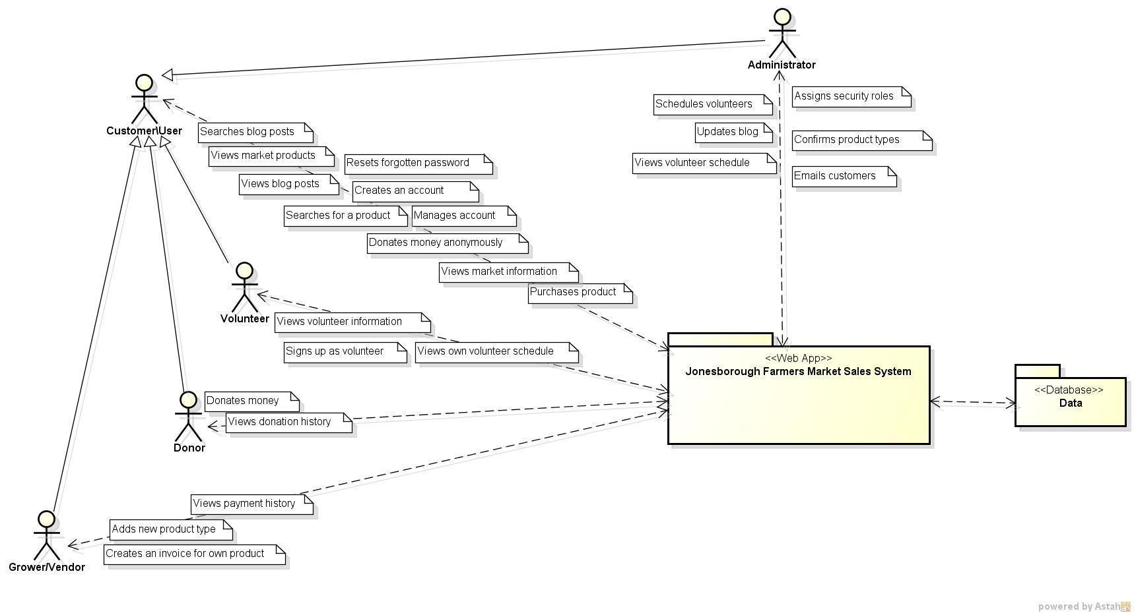

## Functional Requirements

1. The system shall allow a customer to view blog posts
2. The system shall allow a customer to search for a keyword in blog posts
3. The system shall allow a customer to view general information about the Jonesborough Farmer’s Market by accessing the home page, blog page, or Q&A page
   1. These pages shall be viewable by a customer without logging in
   2. These pages shall be formatted in a blog style--each page shall contain posts added by an administrative user
   3. These pages shall be editable only by an administrator
4. The system shall allow a customer to login
5. The system shall allow a customer to create an account
6. The system shall allow a customer to View and Edit their account information by clicking the “Account Management” button
   1. When the “Account Management” button is clicked, the system shall display the Account Management page” which has four buttons (see prototype whiteboard image 2013-10-26 15.12.04.jpg): “Update Account Info”, “Order History”, “Delete Account”, and “Cancel”
   2. The system shall allow a customer to view and edit their account information by clicking the “Account Info” button (see prototype whiteboard image 2013-10-26 15.48.23.jpg) from the Account Management page
      1. The system shall allow a customer to modify Name, Address(like the stuff on the create account page 2013-10-26 15.06.35.jpg), Billing Address, and Payment Type (2013-10-26 15.48.23.jpg)
   3. The system shall allow a customer to view a listing of previously purchased products by clicking the “Order History” button from the Account Management page
      1. When the “Order History” button is clicked, the system shall display the Order History page which includes the Receipt information for each previous purchase (refer to requirement 9 for Receipt info)
      2. The system shall allow the customer to close the Order History page by clicking the “OK” button
   4. The system shall allow a customer to delete their account by clicking the “Delete Account” button from the Account Management page
      1. When the “Delete Account” button is clicked, if the customer is currently logged in, then the Account Deletion Confirmation page is displayed.
      2. The Account Deletion Confirmation page displays the text “Are you sure you want to delete your account?” along with an “OK” button and a “Cancel” button
      3. If the “OK” button is clicked, the Account information is removed from the database
      4. If the “Cancel” button is clicked, the previous page is displayed
7. The system shall allow a customer to reset a forgotten password or username
8. The system shall allow a customer to view available products
9. The system shall allow a customer to purchase available products from the market
   1. The system shall allow a customer to add products to a shopping cart
      1. The system shall allow a customer to type in a number to specify the quantity of a product to add to the shopping cart
      2. The system shall allow a customer to add the specified quantity of product to the shopping cart by clicking an “Add to Shopping Cart” button
      3. The system shall allow a customer to login/create an account if they click the “Add to Shopping Cart” button
   2. The system shall allow a customer to View and Edit their shopping cart
      1. The system shall allow a customer to view their shopping cart by clicking the “Shopping Cart” button
      2. The system shall allow a customer to remove a product from their shopping cart by clicking a checkbox beside the product and then clicking the “Remove” button
   3. The system shall allow a Customer to purchase the products in the shopping cart by clicking the “Checkout” button
      1. The order total shall be displayed on the Checkout page
      2. The system shall allow the Customer to navigate to the Update Account Information page (see requirement 6) from the Checkout page
      3. A receipt shall be displayed when the Customer clicks the “Submit Order” button
      4. A receipt shall be emailed to the Customer when the order is submitted
10. The system shall allow a customer to search for a specific product
11. The system shall allow a customer to donate money anonymously (without creating an account)
12. The system shall allow a customer to view their donation history
13. The system shall allow a customer with an account donate money
14. The system shall maintain a total for donations made by a customer with an account
15. The system shall allow a user to view information on becoming a volunteer
16. The system shall allow a user to sign up as a volunteer
    1. The system shall allow a volunteer to enter the days and times they are available to volunteer
17. The system shall allow a volunteer to view the days and times they are scheduled to do volunteer work
    1. The system shall allow a volunteer to modify their availability on the volunteer schedule
    2. The system shall allow a volunteer to contact an administrator about a volunteer scheduling conflict
18. The system shall allow a grower to add a new product type
19. The system shall allow a grower to create an invoice for their products
    1. The system shall allow a grower to add the quantity of a product type they are going to bring to the market
    2. The system shall allow a grower to specify the date that they will bring the invoice items to the market
    3. The system shall allow a grower to confirm their invoice
20. The system shall allow a grower to view their invoice history
21. The system shall allow a grower to view their payment history
22. The system shall allow an administrator to assign security roles to users
23. The system shall allow an administrator to schedule volunteers
    1. The system shall allow an administrator to view confirmed schedules
    2. The system shall allow an administrator to view unconfirmed schedules
24. The system shall allow an administrator to confirm product types
25. The system shall allow an administrator to update blog

## Non-functional Requirements

1. The system shall support four major web browsers (Chrome, FireFox, Internet Explorer, Safari).
2. The system shall provide search results within 5 seconds.
3. The system shall allow the user to have 5 incorrect logins before locking the user’s account for 3 hours.
4. When a user requests a password reset, the system shall reset the user’s password within one hour.
5. The system shall commit user updates to his/her account information within 3 seconds.
6. When a user adds an item to his/her shopping cart, the system shall update the user’s shopping cart within 2 seconds.
7. When a user removes an item from his/her shopping cart, the system shall update the user’s shopping cart within 2 seconds.
8. The system shall create a receipt for a completed checkout within 3 seconds of the transactions completion.
9. The system shall update the total for the user’s cart within 3 seconds of any change made to the cart.
10. The system will complete a money transaction for a purchase or donation within 5 business days.
11. The system shall update product inventory within 5 minutes of a product being added to inventory.
12. The system shall update product inventory with 30 seconds of a product being removed from inventory.
13. The system shall email a receipt to the customer within 1 minute of a transactions completion.
14. The system shall hash and salt passwords as follows, SHA-224((first 6 characters of password) append (MD5 of username) append (remaining characters of password in reverse order)).
15. The system shall parameterize all queries.
16. The system shall validate all user inputs from checkboxes and buttons.

## User-Interface Requirements

1. Blog posts shall be written in Times New Roman font.
2. Blog posts shall be formatted so that a text reader will be able to read the blog posts.
3. All images on the website shall provide alternate texts.
4. The website shall follow all usability practices that have been outlined by guidelines.usability.gov.
5. The system shall present all information with color-blindness compliance.
6. The system shall allow users to use the tab key to set through the inputs of any forms.
7. The menu bar for the website shall be in the same location for all web pages.
8. A common theme for fonts and color schemes shall be used for the entire website.
9. All collapsible elements shall be clearly marked with the standard convention of a left pointing triangle <| or a right pointing triangle |> for collapsed element and a downward pointing triangle for  uncollapsed elements.
10. The link for the user account and the link to login/logout shall be located in the top right corner of the website.
11. The system shall format the credit card expiration date, as part of the user’s billing information, to be mm/yyyy with mm being the month and yyyy being the year.
12. All hyperlinks on the website shall be identifiable with bolded text, altered colored from surrounding text, and change the mouse pointer, when hovered on, from the normal select to the link select.
13. The system shall refrain from using implicit user interaction, such as right-click for menu options or hotkeys.
14. The system shall refrain from creating pop-up windows or new tabs for web content.

## 

## Data Storage Requirements

(Select View>Zoom for more detail)

d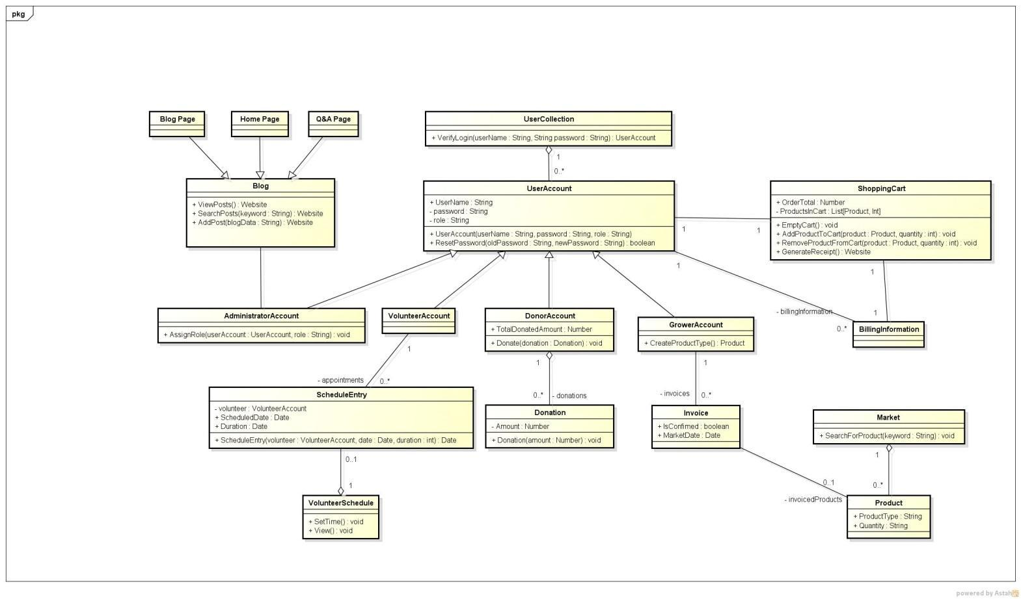

## Data Dictionary

|  |  |  |
| --- | --- | --- |
| **Name** | **Type of Data** | **Description** |
| **Address** | Textual | User’s place of residence |
| **Donation History** | Textual | Listing of money donated by a particular donor over a period of time |
| **Donation Total** | Numeric | Total amount of money donated by a particular donor over a period of time |
| **First Name** | Textual | User’s given name |
| **Inventory** | Textual | Listing of all items currently offered for sale |
| **Keyword** | Textual | A String the system searches for in blog posts |
| **Last Name** | Textual | User’s family or surname |
| **Order Total** | Numeric | The amount of money necessary to purchase all items placed in the shopping cart |
| **Password** | Textual | A String generated by the system for use only by the given customer. It allows the customer to login to his or her account |
| **Product Types** | Textual | New categories of products that can be added by growers/vendors |
| **Quantity** | Numeric | A number assigned to products telling the number available |
| **Username** | Textual | Name used to differentiate between users |
| **Volunteer Availability** | Textual | The times volunteers are able to volunteer |